**WELCOME TO**

**HTML MASTERY COURSE : THE ULTIMATE GUIDE !**



**HTML**

**CSS**

**JAVASCRIPT**

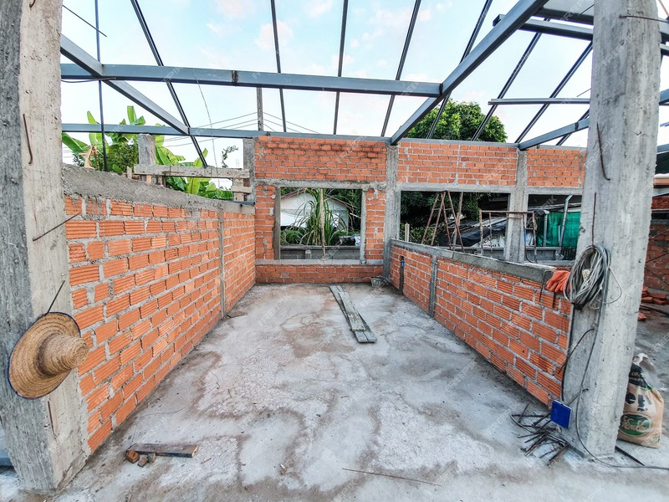

# LEVEL 1

**What is HTML?**

HTML stands for Hyper Text Markup Language

HTML is the standard markup language for creating Web pages HTML describes the structure of a Web page

HTML consists of a series of elements

HTML elements tell the browser how to display the content HTML elements label pieces of content such as "this is a heading", "this

is a paragraph", "this is a link", etc.

**BASIC HTML STRUCTURE**

**<!DOCTYPE html>**

**<html>**

**<head>**

**<title>Page Title</title>**

**</head>**

**<body>**

**<h1>My First Heading</h1>**

**<p>My first paragraph.</p>**

**</body>**

**</html></html>**

**The <!DOCTYPE html> declaration defines that this document is an HTML5 document**

**The <html> element is the root element of an HTML page**

**The <head> element contains meta information about the HTML page The <title> element specifies a title for the HTML page (which is shown in the browser's title bar or in the page's tab)**

**The <body> element defines the document's body, and is a container for all the visible contents, such as headings, paragraphs, images, hyperlinks, tables, lists, etc.**

**The <h1> element defines a large heading The <p> element defines a paragraph**

**What is an HTML Element?**

**An HTML element is defined by a start tag, some content, and an end tag:**

**<tagname> Content goes here... </tagname>**

**The HTML element is everything from the start tag to the end tag:**

**<h1>My First Heading</h1>**

**<p>My first paragraph</p>**

**HTML is NOT case sensitive**

**<HTML> = <html>**

**<p> = <P>**

**<H1> = <h1>**

# LEVEL 2

**DOWNLOAD AN IDE OR CODE EDITOR**



**INSTALL VS CODE BECAUSE THIS IS THE BEST IDE IN THE INDUSTRY**

### DOWNLOAD VS CODE EXTENSIONS

**LIVE SERVER PRETTIER**

# START CODING

**CREATE A FOLDER CREATE A FILE WITH (INDEX.HTML)**

**GENERATE HTML BOILER PLATE WITH (SHIFT + !)**

# LEVEL 3

**COMMENTS IN HTML**

**Used to add notes in HTML code**

**This is part of code that should not be parsed.**

**Not displayed on the web page .**

**Syntax: <!-- COMMENT -->**

**WHAT ARE HTML ATTRIBUTES ?**

**All HTML elements can have attributes Attributes provide additional information about elements**

**Attributes are always specified in the start tag Attributes usually come in name/value pairs like: name="value"**

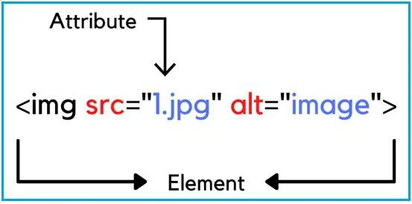

## HTML Headings

**HTML headings are defined with the <h1> to <h6> tags.**

**<h1> defines the most important heading.**

**<h6> defines the least important heading.**

**<h1>Heading 1</h1>**

**<h2>Heading 2</h2>**

**<h3>Heading 3</h3>**

**<h4>Heading 4</h4>**

**<h5>Heading 5</h5>**

**<h6>Heading 6</h6>**

## HTML Paragraphs

**The HTML <p> element defines a paragraph.**

**A paragraph always starts on a new line, and browsers automatically add some white space (a margin) before and after a paragraph.**

**<p>This is a paragraph.</p>**

**<p>This is another paragraph.</p>**

## HTML <pre> Tag

**The <pre> tag defines preformatted text.**

**Text in a <pre> element is displayed in a fixed- width font, and the text preserves both spaces and line breaks. The text will be displayed exactly as written in the HTML source code.**

**<pre>This is a pre with a fixed width. It will use as much space as specified.</pre>**

**BR TAG - FOR LINE BREAK (<BR>)**

**HR TAG - FOR HORIZONTAL LINE (<HR>)**

**THESE TAGS ARE SELF CLOSING TAGS. DO NOT REQUIRED CLOSING TAG.**

# FORMATTING TAGS OF HTML

**b - FOR BOLD TEXT i - FOR ITALIC TEXT**

**em - ALTERNATIVE OF i TAG u - FOR UNDERLINE**

**del - FOR DELETE TEXT s - ALTERNATIVE OF DEL**

**mark - FOR HIGHLIGHTING THE TEXT big - FOR TEXT SIZE INCREASE**

**small - FOR TEXT SIZE DECREASE sub - FOR SUBSCRIPT TEXT**

**sup - FOR SUPERSCRIPT TEXT**

# LEVEL 4

## HTML <a> Tag

**The <a> tag defines a hyperlink, which is used to link from one page to another.**

**The most important attribute of the <a> element is the href attribute, which indicates the link's destination.**

**<a href="https://**[**www.tishantagrawal.com**](http://www.tishantagrawal.com/)**">Visit Our Website</a>**

## HTML iframe Tag

**The HTML <iframe> tag specifies an inline frame.**

**An inline frame is used to embed another document within the current HTML document. You can also embed Youtube video within iframe tag.**

**Use the height and width attributes to specify the size of the iframe.**

**<iframe src="**[**https://tishantagrawal.com/**](https://tishantagrawal.com/)**" height="200" width="300" title="Our website"></iframe>**

## HTML <img> Tag

**The <img> tag is used to embed an image in an HTML page.**

**Images are not technically inserted into a web page; images are linked to web pages. The <img> tag creates a holding space for the referenced image.**

**The <img> tag has two required attributes: src - Specifies the path to the image**

**alt - Specifies an alternate text for the image, if the image for some reason cannot be displayed**

**<img src="img_girl.jpg" alt="Image not found" width="500" height="600">**

## HTML <video> Tag

**The <video> tag is used to embed video content in a document, such as a movie clip or other video streams.**

**ATTRIBUTES - src, autoplay, controls, loop, muted, width , height**

**<video width="320" height="240" controls src="taj.mp4"> </video>**

## HTML <audio> Tag

**The <audio> tag is used to embed sound content in a document, such as music or other audio streams.**

**ATTRIBUTES - src, autoplay, controls, loop, muted, width , height**

**<audio width="320" height="240" controls src="taj.mp3"> </audio>**

## HTML <embed> Tag

**The <embed> tag defines a container for an external resource, such as a web page, a picture, a media player, or a plug-in application.**

<embed type="image/jpg" src="pic_trulli.jpg" width="300" height="200">

**<embed type="video/webm" src="video.mp4" width="400" height="300">**

<embed type="audio/mp3" src="audio.mp3" width="400" height="300">

## HTML <base> Tag

**The <base> tag in HTML is used to specify a base URL for all relative URLs within a document. It's typically placed within the <head> section of an HTML document and does not require a closing tag.**

**<!DOCTYPE html>**

**<html>**

**<head>**

**<base href="https://example.com">**

**<title>Document Title</title>**

**</head>**

**<body>**

**<a href="page.html">Link</a>**

**</body>**

**</html>**

## HTML <abbr> Tag

**In HTML, the "abbr" tag is used to define an abbreviation or an acronym. It stands for "abbreviation." The purpose of the "abbr" tag is to provide a semantic indication of shortened or abbreviated text, which can help assistive technologies and search engines understand the content better.**

**<p>The <abbr title="World Health Organization">WHO</abbr> was founded in 1948.</p>**

## HTML <bdo> Tag

**In HTML, the <bdo> tag stands for "Bi-Directional Override." It is used to override the default text direction of the document and force the text to be displayed in a specified direction, regardless of the surrounding text directionality. This tag is particularly useful when dealing with languages that are written from right to left (RTL), such as Arabic or Hebrew, within an HTML document that is predominantly left-to-right (LTR).**

**<p>This text is in the default direction.</p>**

**<bdo dir="rtl">This text will be displayed right-to-left.**

**</bdo>**

## HTML <button> Tag

**In HTML, the <button> tag is used to create a clickable button. It's commonly used within forms to submit or reset the form, but it can also be used for other types of interactive elements.**

**<button type="button">Click me!</button>**

## HTML <meter> Tag

**<meter> Element: The <meter> element represents a scalar measurement within a known range, or a fractional value. It's used to create graphical meters or gauges that show the current level of a value within a known range. Here's an example:**

**html**

**<meter value="50" min="0" max="100">60%</meter>**

## HTML <progress> Tag

**<progress> Element: The <progress> element represents the completion progress of a task. It's typically used to show the progress of a lengthy operation, such as file downloads, installations, or data processing. Here's an example:**

**<progress value="70" max="100">70%</progress>**

# LEVEL 5

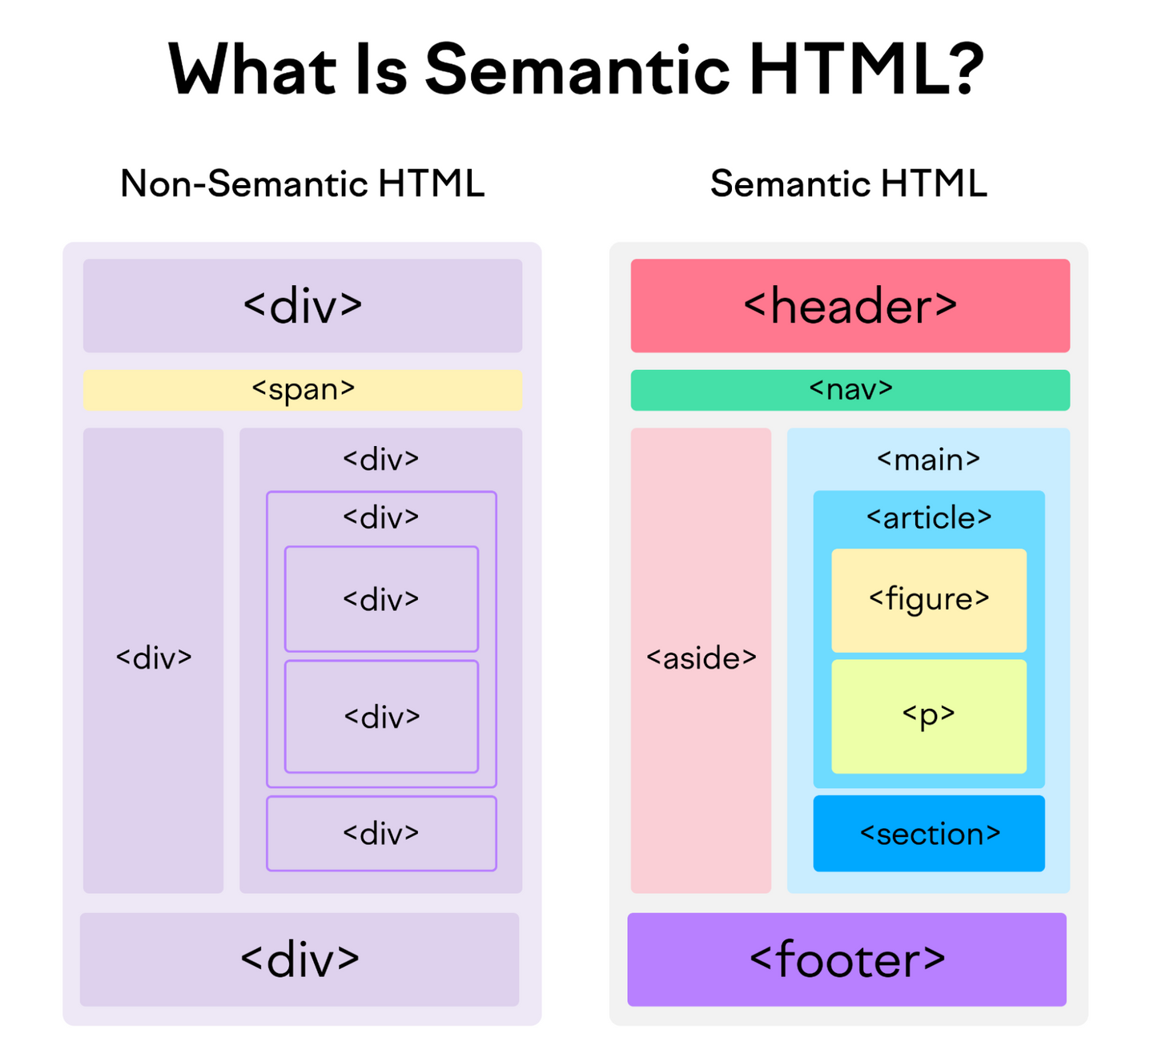

## HTML <header> Tag

**The <header> element represents a container for introductory content or a set of navigational links.**

**A <header> element typically contains: one or more heading elements (<h1> - <h6>)**

**logo or icon authorship information**

**<header>**

**<h1>A heading here</h1>**

**<p>Posted by John Doe</p>**

**<p>Some additional information here</p>**

**</header>**

## HTML <main> Tag

**The <main> tag specifies the main content of a document.**

**The content inside the <main> element should be unique to the document. It should not contain any content that is repeated across documents such as sidebars, navigation links, copyright information, site logos, and search forms. Note: There must not be more than one <main> element in a document. The**

**<main> element must NOT be a descendant of an <article>, <aside>,**

**<footer>, <header>, or <nav> element.**

**<main>**

**<article>**

**<h2>Google Chrome</h2>**

**<p>Google Chrome is a web browser developed by Google, released in 2008.**

**Chrome is the world's most popular web browser today!</p>**

**</article>**

**</main>**

## HTML <section> Tag

**In HTML, the <section> tag is used to define sections in a document.**

**It is a semantic HTML5 tag that helps in structuring and organizing content. The <section> tag is often used to group related content together and typically represents a thematic grouping of content, such as chapters, headers, or different topics.**

<section>

<h2>WWF History</h2>

<p>The World Wide Fund for Nature (WWF) is an international organization working on issues regarding the conservation, research and restoration of the environment, formerly named the World Wildlife Fund. WWF was founded in 1961.</p>

</section>

## HTML <article> Tag

**The <article> tag specifies independent, self-contained content.**

**An article should make sense on its own and it should be possible to distribute it independently from the rest of the site.**

**Potential sources for the <article> element:**

**Forum post Blog post News story**

**<article>**

**<h1>Sample Article</h1>**

**<p>This is the content of the article.</p>**

**<!-- Additional content goes here -->**

**</article>**

## [HTML aside Tag](https://www.w3schools.com/tags/tag_aside.asp)

In HTML, the <aside> tag is used to define content that is tangentially related to the content around it. It is typically used for content such as sidebars, pull quotes, or other information that is related to the main content but not considered the primary focus. The <aside> content can be placed inside an <article> or outside it.

**<aside>**

**<h2>Related Information</h2>**

**<p>Additional information that is related to the main content.</p>**

**</aside>**

## [HTML footer Tag](https://www.w3schools.com/tags/tag_footer.asp)

**In HTML (Hypertext Markup Language), the <footer> tag is used to define a footer for a document or section. It typically contains metadata, copyright information, links to terms of service, privacy policy, contact information, or other relevant details. The <footer> tag is part of the HTML5 specification and is commonly used to structure the content of a webpage.**

**<footer>**

**<p>&copy; 2023 Your Website Name. All rights reserved.</p>**

**<p>Contact:** [**your@email.com**](mailto:your@email.com)**</p>**

**</footer>**

# BLOCK VS INLINE ELEMENTS

**Block-level Elements**

**A block-level element always starts on a new line, and the browsers automatically add some space (a margin) before and after the element.**

**A block-level element always takes up the full width available (stretches out to the left and right as far as it**

**can).**

**Two commonly used block elements**

**are: <p> and <div>.**

**Inline Elements**

**An inline element does not start on a new line.**

**An inline element only takes up as much width as**

**necessary.**

**Two commonly used block**

**elements are: <a> and <span>.**

## HTML <div> Element

**The <div> element is often used as a container for other HTML elements.**

**The <div> element has no required attributes, but style, class and id are common.**

**When used together with CSS, the <div> element can be used to style blocks of content:**

**<div>**

**<h2>London</h2>**

**<p>London is the capital city of England. </p>**

**</div>**

## HTML <span> Element

**The <span> element is an inline container used to mark up a part of a text, or a part of a document.**

**The <span> element has no required attributes, but style, class and id are common.**

**When used together with CSS, the <span> element can be used to style parts of the text:**

**<p>**

**My mother has**

**<span> blue eyes and my father has dark green eyes. <span/>**

**</p>**

**LEVEL 6**

**LISTS IN HTML**

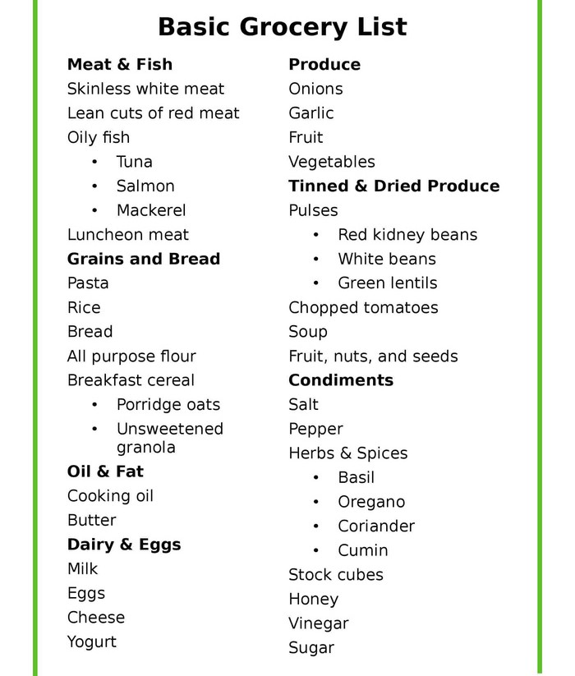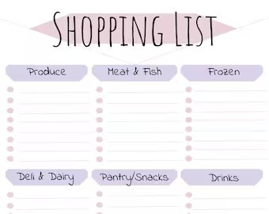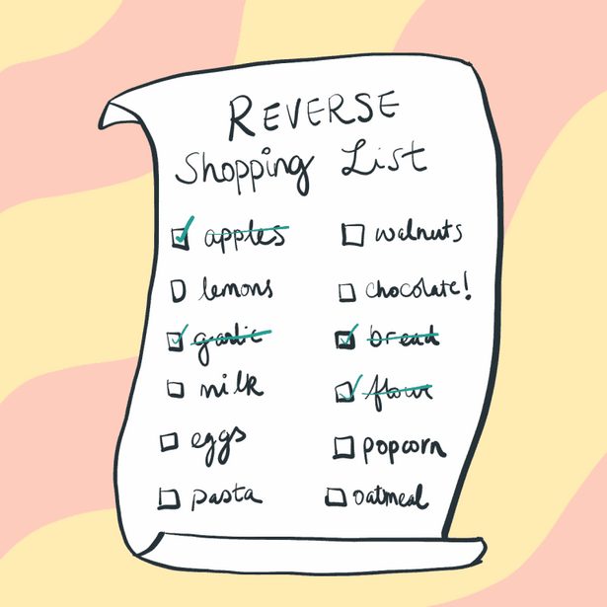

**EXAMPLES OF LISTS**

**An unordered HTML list:**

**Item Item Item Item**

**An ordered HTML list:**

1. **First item**
2. **Second item**
3. **Third item**
4. **Fourth item**

## Unordered HTML List

**An unordered list starts with the <ul> tag. Each list item starts with the <li> tag.**

**The list items will be marked with bullets (small black circles) by default:**

**<ul type=”square”>**

**<li>Coffee</li>**

**<li>Tea</li>**

**<li>Milk</li>**

**</ul>**

**TYPES OF UNORDER LIST**

* 1. **SQUARE**
  2. **DISC**
  3. **CIRCLE**

## Ordered HTML List

**An ordered list starts with the <ol> tag. Each list item starts with the <li> tag.**

**The list items will be marked with numbers by default:**

**TYPES OF ORDERED LIST**

**<ol type=”1”>**

**<li>Coffee</li>**

**<li>Tea</li>**

**<li>Milk</li>**

**</ol>**

**1**

**A**

**a I**

**i**

# DROPDOWN LIST

**The <select> element is used to create a drop-down list.**

**The <select> element is most often used in a form, to collect user input. The name attribute is needed to reference the form data after the form is submitted (if you omit the name attribute, no data from the drop- down list will be submitted).**

**The id attribute is needed to associate the drop-down list with a label.**

**<label for="cars">Choose a car:</label>**

**<select name="cars" id="cars">**

**<option value="volvo">Volvo</option>**

**<option value="saab">Saab</option>**

**</select>**

# DATALIST LIST

**The <datalist> tag specifies a list of pre-defined options for an <input> element.**

**The <datalist> tag is used to provide an "autocomplete" feature for <input> elements. Users will see a drop-down list of pre-defined options as they input data.**

**The <datalist> element's id attribute must be equal to the <input> element's list attribute (this binds them together).**

**<label for="browser">Choose your browser from the list:</label>**

**<input list="browsers" name="browser" id="browser">**

**<datalist id="browsers">**

**<option value="Edge">**

**<option value="Firefox"**

**</datalist>**

## HTML <table> Tag

1. **<tr> Table Row : Used to define a row in an**

**HTML table.**

1. **<th> Table Header : Used for header cells within a row. Text is bold and centered by default.**
2. **<td> Table Data : This Holds the actual data.**

**<table>**

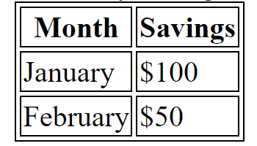**<tr>**

**<th>Month</th>**

**<th>Savings</th>**

**</tr>**

**<tr>**

**<td>January</td>**

**<td>$100</td>**

**</tr>**

**</table>**

**<table>**

**<caption> Monthly savings </caption>**

**<tr>**

**<th>Month</th>**

**<th>Savings</th>**

**</tr>**

**<tr>**

**<td>January</td>**

**<td>$100</td>**

**</tr>**

**<tr>**

**<td>February</td>**

**<td>$50</td>**

**</tr>**

**</table>**

### CAPTION TAG

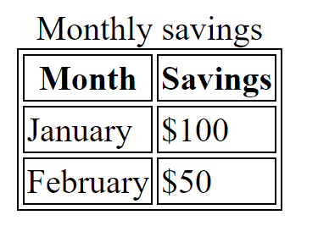

**HTML <thead>, <tbody> &<tfoot> Tag**

**The <thead> tag is used to group header content in an HTML table.**

**The <thead> element is used in conjunction with the** [**<tbody>**](https://www.w3schools.com/tags/tag_tbody.asp) **and**

[**<tfoot>**](https://www.w3schools.com/tags/tag_tfoot.asp) **elements to specify each part of a table (header, body, footer).**

**Note: The <thead> element must have one or more**

[**<tr>**](https://www.w3schools.com/tags/tag_tr.asp) **tags inside.**

# COLSPAN

**To make a cell span over multiple columns, use the colspan attribute:**

**<table style="width:100%">**

**<tr>**

**<th colspan="2">Name</th>**

**<th>Age</th>**

**</tr>**

**<tr>**

**<td>Jill</td>**

**<td>Smith</td>**

**<td>43</td>**

**</tr>**

**<tr>**

**<td>Eve</td>**

**<td>Jackson</td>**

**<td>57</td>**

**</tr>**

**</table>**

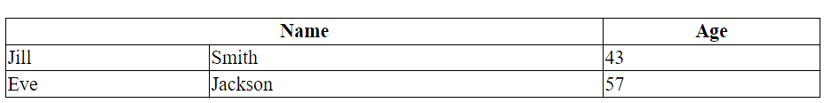

# ROWSPAN

**<table style="width:100%">**

**<tr>**

**<th>Name</th>**

**<td>Jill</td>**

**</tr>**

**<tr>**

**<th rowspan="2">Phone</th>**

**<td>555-1234</td>**

**</tr>**

**<tr>**

**<td>555-8745</td>**

**</tr>**

**</table>**

**To make a cell span over multiple rows, use the rowspan attribute:**

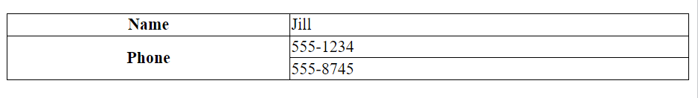

# FORMS IN HTML

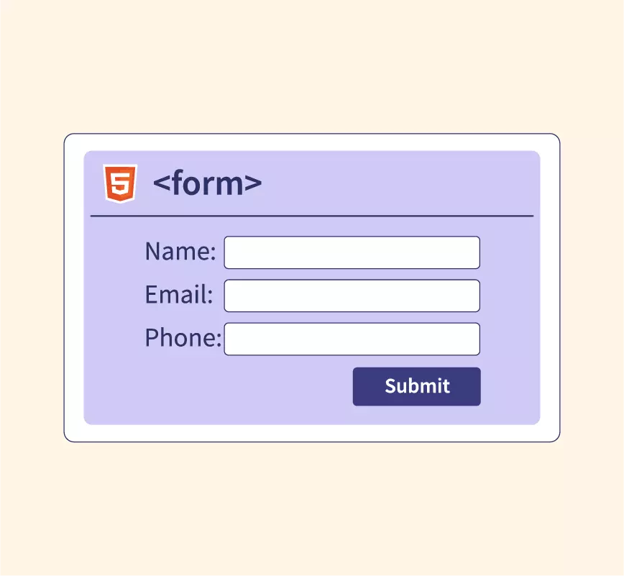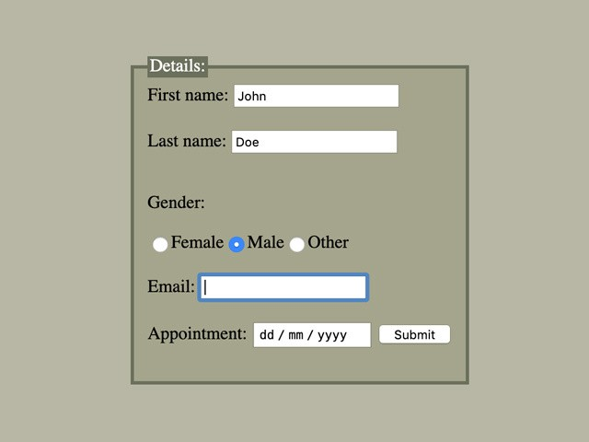

**ACTION ATTRIBUTE**

**The action attribute specifies where to send the form-data when a form is submitted.**

**NAME AND VALUE PROPERTY**

**The name attribute specifies the name of an <input> element.**

**The value attribute specifies the value of an <input> element.**

# LABEL TAG

**In HTML, the <label> tag is used to define a label for an <input>,**

**<select>, <textarea>, or <button> element. The label tag provides a user-friendly description for the associated form element, making it more accessible and easier to understand for users.**

**<label for="username">Username:</label>**

**<input type="text" id="username" name="username">**

**HTML <input> Tag**

**The <input> tag specifies an input field where the user can enter data.**

**The <input> element is the most important form element.**

**The <input> element can be displayed in several ways, depending on the type attribute.**

**<input type="text" id="fname" name="fname">**

**The different input types are as follows:**

**<input type="button">**

**<input type="checkbox">**

**<input type="color">**

**<input type="date">**

**<input type="datetime-local">**

**<input type="email">**

**<input type="file">**

**<input type="hidden">**

**<input type="image">**

**<input type="month">**

**<input type="number">**

**<input type="password">**

**<input type="radio">**

**<input type="range">**

**<input type="reset">**

**<input type="search">**

**<input type="submit">**

**<input type="tel">**

**<input type="text"> (default value)**

**<input type="time">**

**<input type="url">**

**<input type="week">**